Supplementary material

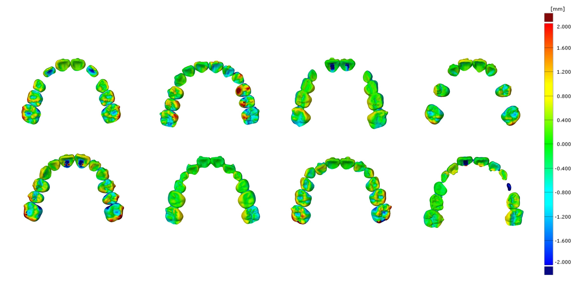
Supplementary Fig. 1. The discrepancy between predicted and achieved tooth models in mixed-dentition group. The amount of discrepancy is presented by color-coded mapping.

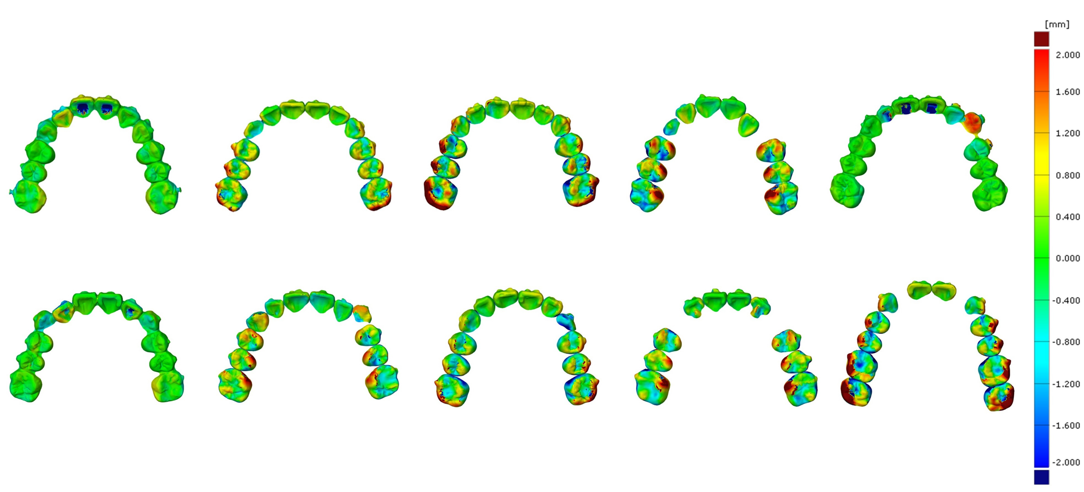
Supplementary Fig. 2. The discrepancy between predicted and achieved tooth models in permanent-dentition group. The amount of discrepancy is presented by color-coded mapping.

